Guide to Setting Up the Database in PostgreSQL
Objective:
The objective of this guide is to provide clear and concise instructions for setting up the CancerClinicalTrials database in PostgreSQL, ensuring proper database creation and configuration for managing clinical trials records.

Step 1: Creating the database
- Open pgAdmin.
- Type your credentials to connect.
- Right-click on “Local” then "Database" node in the Object Explorer pane.
- Select “Create” then "Database" from the context menu.
- Enter the name of the database: CancerClinicalTrials.

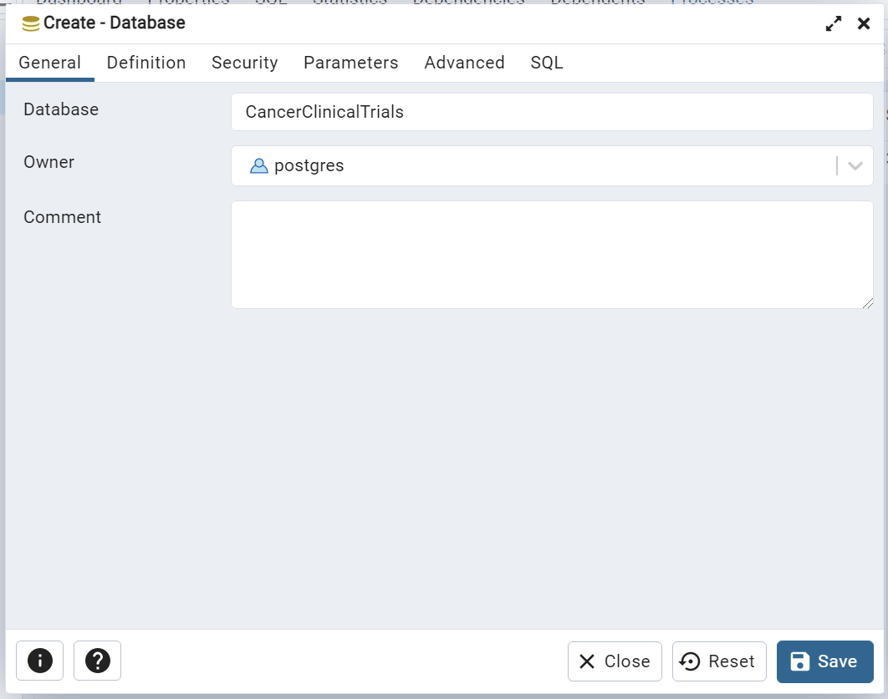

- Click Save to create the database.

Step 2: Importing tables
- Navigate to CancerClinicalTrials > Schemas > Public.
- Right-click on “Tables” then select "Query Tool" in the Object Explorer pane.
- Copy and paste the sql content from CancerClinicalTrials.sql located in docs folder.

